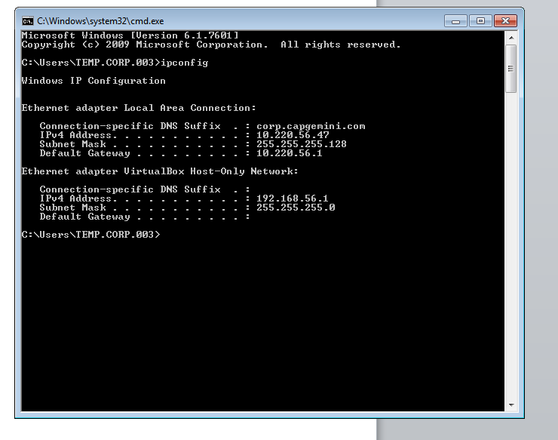

For finding ip config of the system.

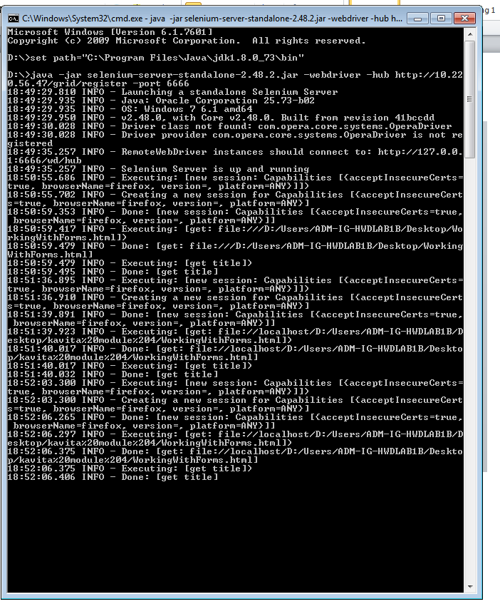

For creating node file

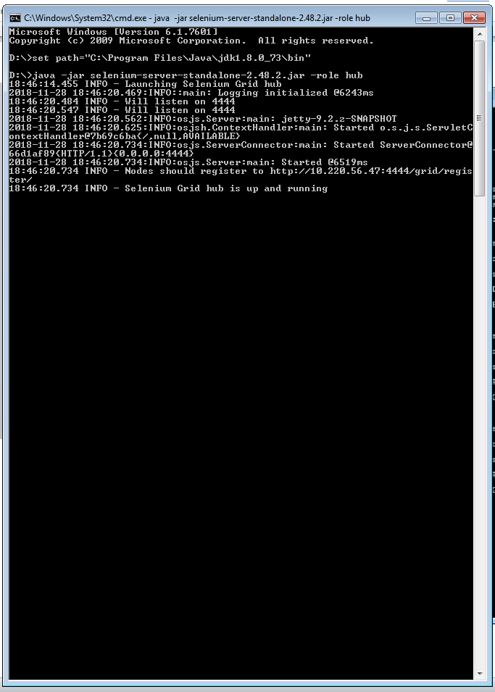

For creating hub note the last second line

Node should be registered at which address is provided by the hub